Width

Definition
# Source: AI Source: Provided by: [Data Path: Persons Table -> ID Column: 1, Name_En Column: Motasem Essam] -> From: [ChatGPT] on [7/20/2026]
In geometry, width is the horizontal or transverse dimension of a geometric object or region, measured from one side to the opposite side.
In simple terms:
Width describes how wide a figure or object is.
$$\boxed{\text{Width}=\text{Distance across a figure from side to side}}$$
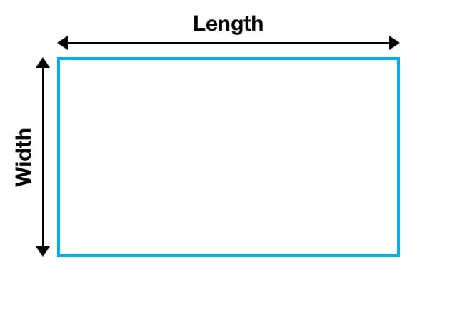
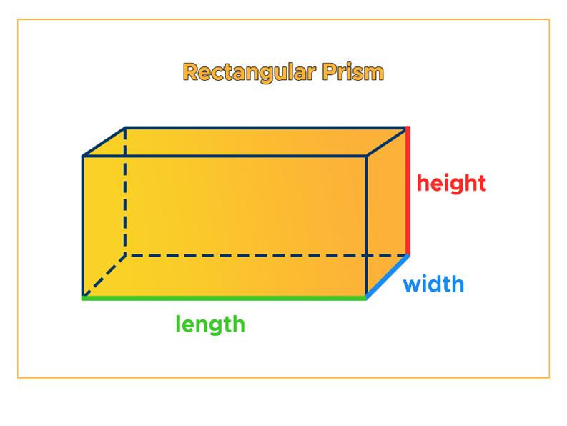
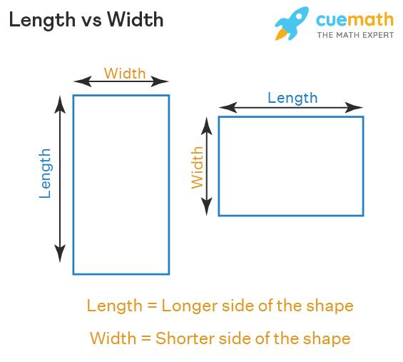
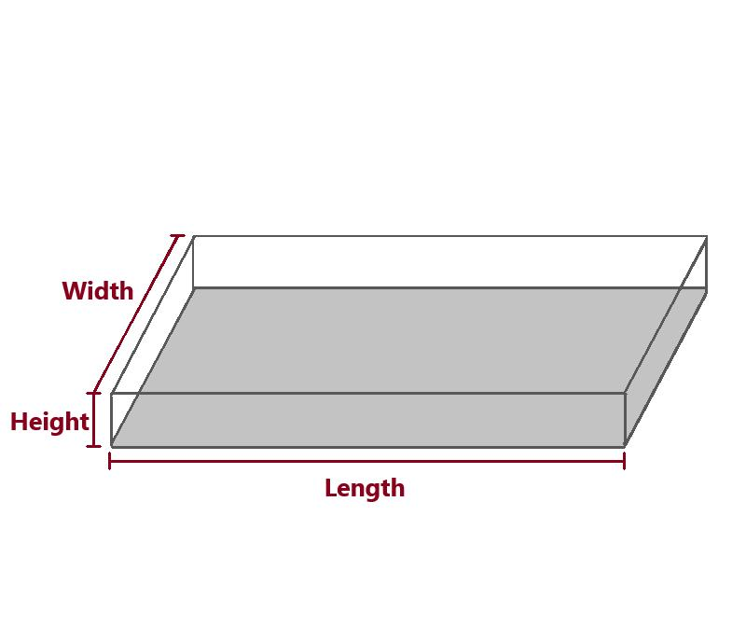

Characteristics
# Source: AI Source: Provided by: [Data Path: Persons Table -> ID Column: 1, Name_En Column: Motasem Essam] -> From: [ChatGPT] on [7/20/2026]
Width typically:
- Is a length measurement.
- Measures the extent of an object from side to side.
- Is often represented by (w).
- Is commonly paired with length (l) and height (h).
- Can be measured in units such as centimeters, meters, inches, or feet.
- Is used in calculations of area, perimeter, surface area, and volume.
$$\boxed{w≥0}$$

Width in Plane Geometry

1. Rectangle
# Source: AI Source: Provided by: [Data Path: Persons Table -> ID Column: 1, Name_En Column: Motasem Essam] -> From: [ChatGPT] on [7/20/2026]
For a rectangle, width is one of its two side dimensions.
$$\boxed{A=lw}$$
where:
- $l$ = length
- $w$ = width
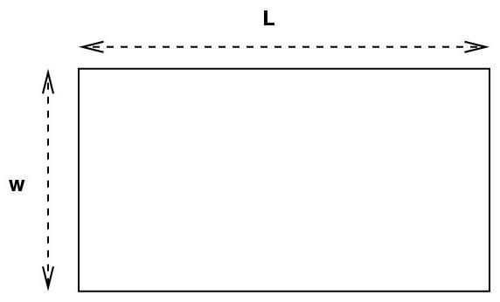
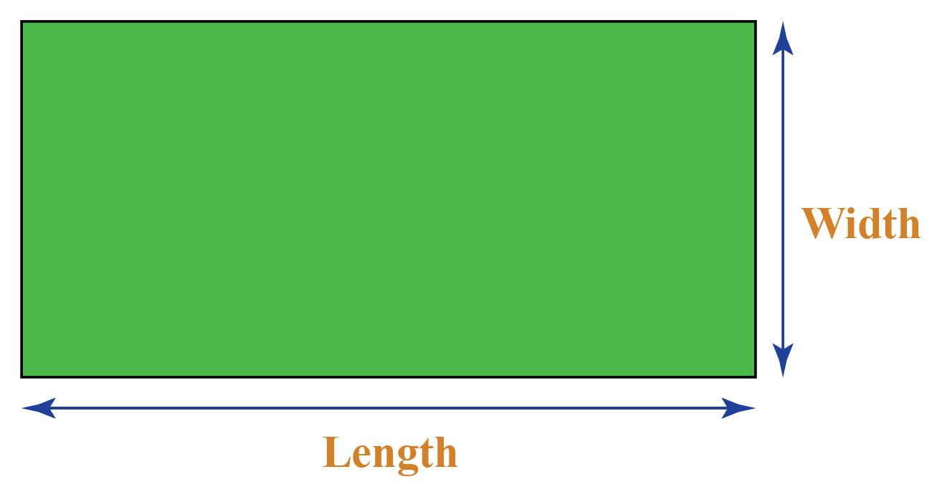
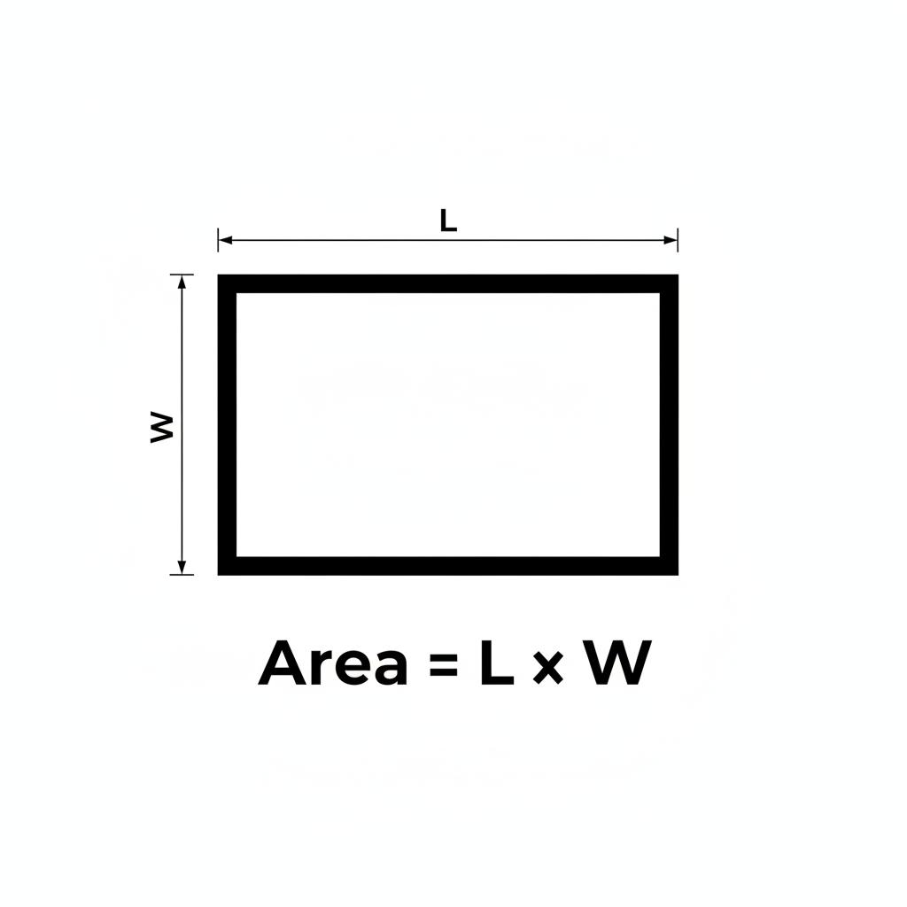
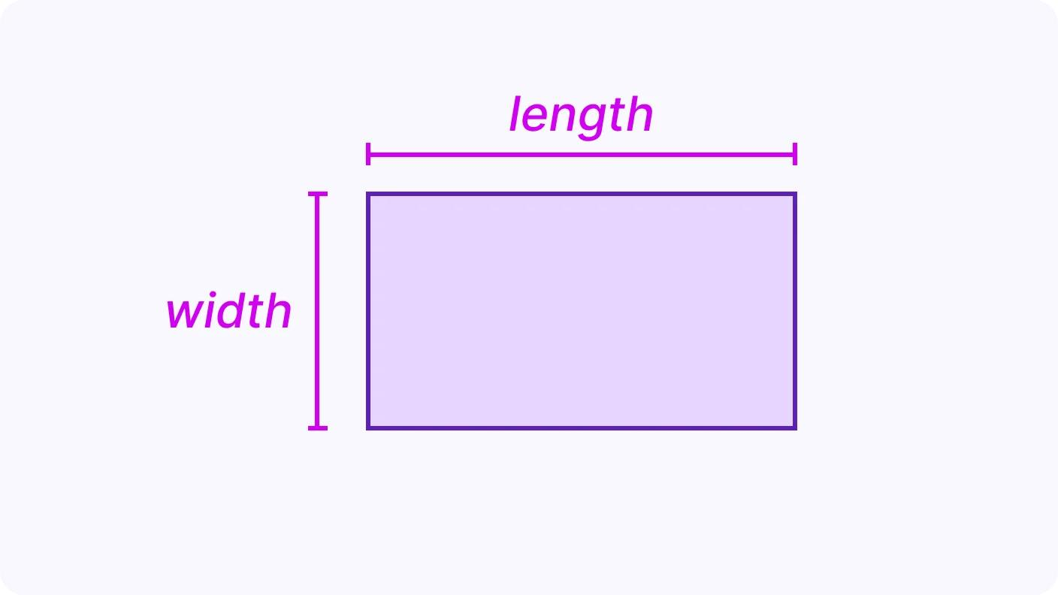
The perimeter is:
$$\boxed{P=2\left(l+w\right)}$$

2. Square
# Source: AI Source: Provided by: [Data Path: Persons Table -> ID Column: 1, Name_En Column: Motasem Essam] -> From: [ChatGPT] on [7/20/2026]
A square has equal dimensions, so its width equals its length:
$$\boxed{w=l=s}$$
Its area is:
$$A=s^{2}$$
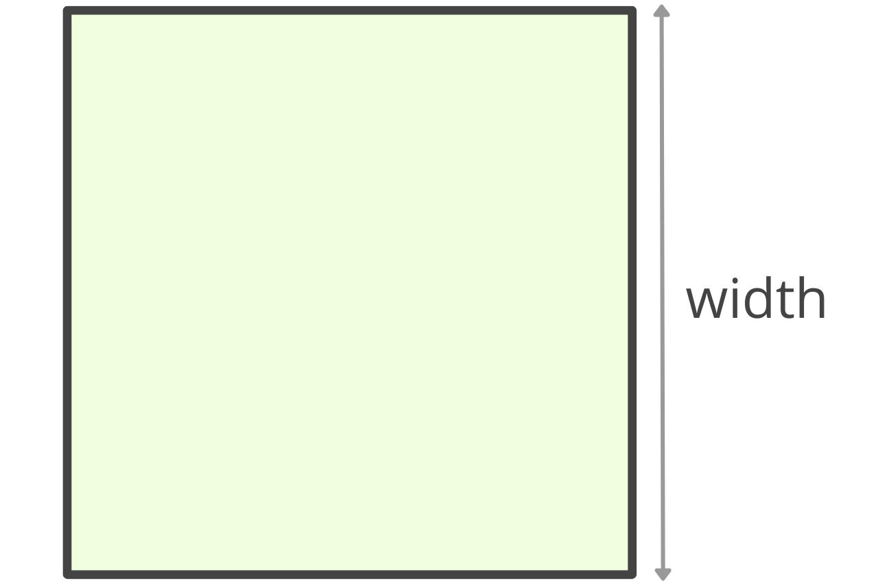
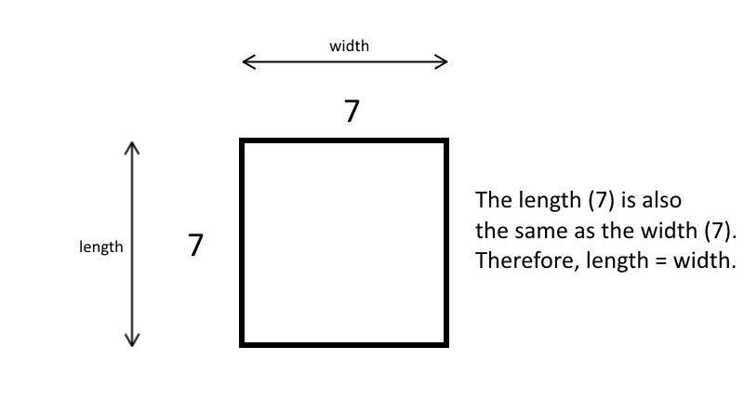
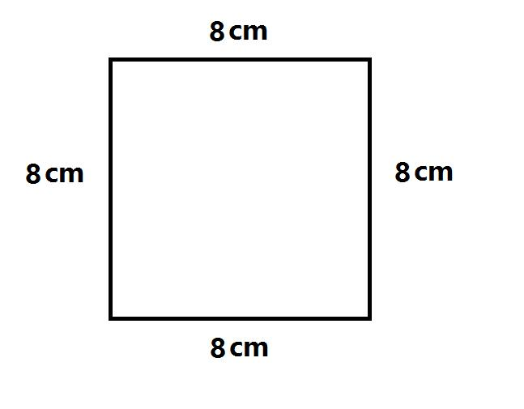

3. Parallelogram
# Source: AI Source: Provided by: [Data Path: Persons Table -> ID Column: 1, Name_En Column: Motasem Essam] -> From: [ChatGPT] on [7/20/2026]
The width may describe the transverse dimension of a parallelogram, depending on the chosen orientation.
However, for area calculations, the more precise terms are base and perpendicular height:
$$\boxed{A=bh}$$
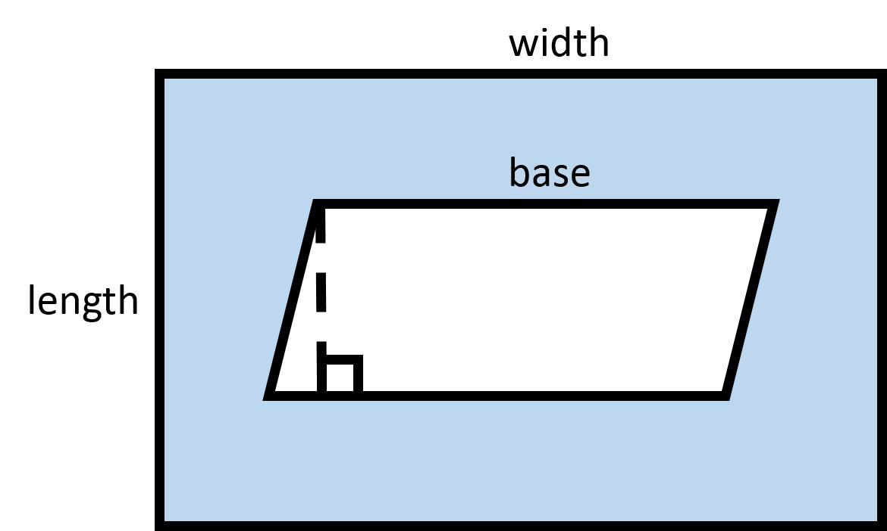
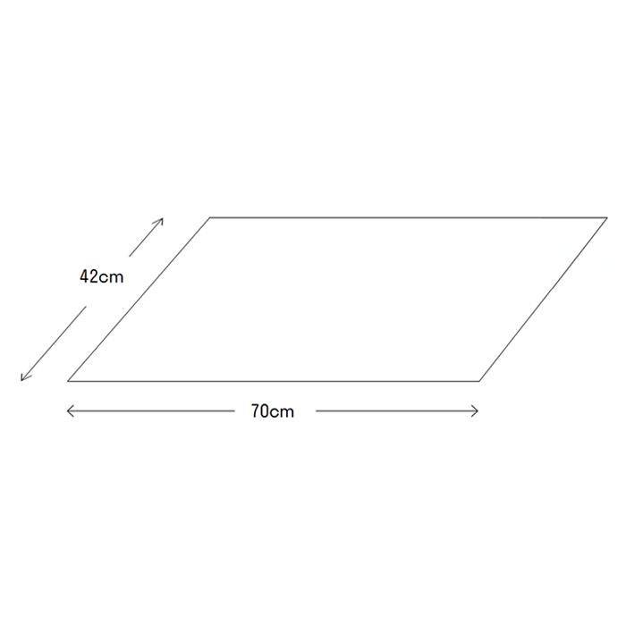
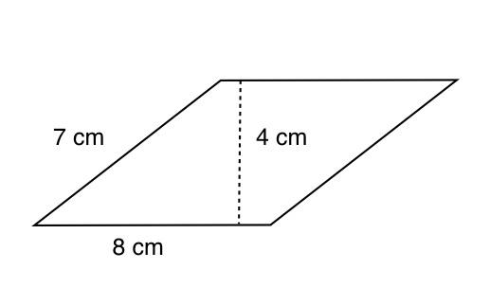
The word width is therefore more dependent on the figure's orientation than base and height.

Width in Solid Geometry
For a 3D object, width is one of the dimensions describing its spatial extent.

Rectangular Prism
# Source: AI Source: Provided by: [Data Path: Persons Table -> ID Column: 1, Name_En Column: Motasem Essam] -> From: [ChatGPT] on [7/20/2026]
A rectangular prism commonly has:
$$\boxed{V=lwh}$$
where:
- $l$ = length
- $w$ = width
- $h$ = height

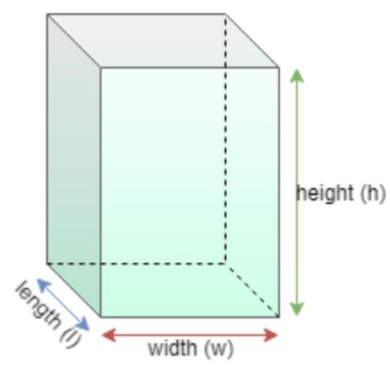
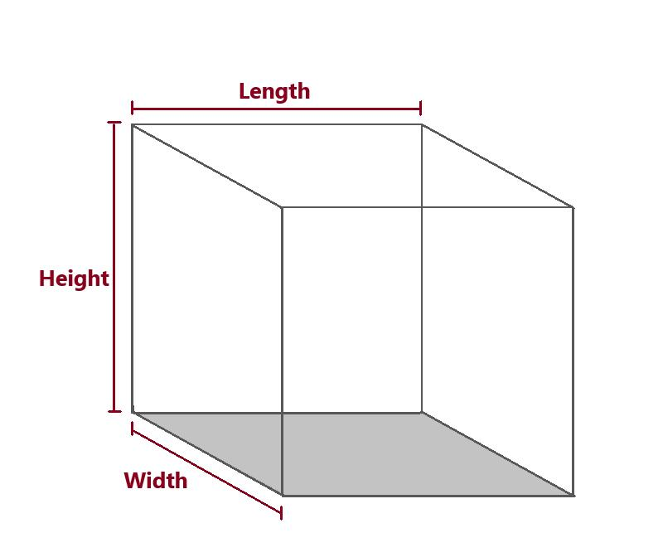
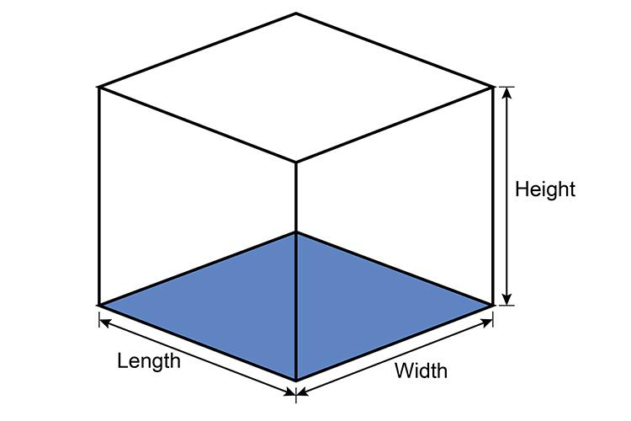
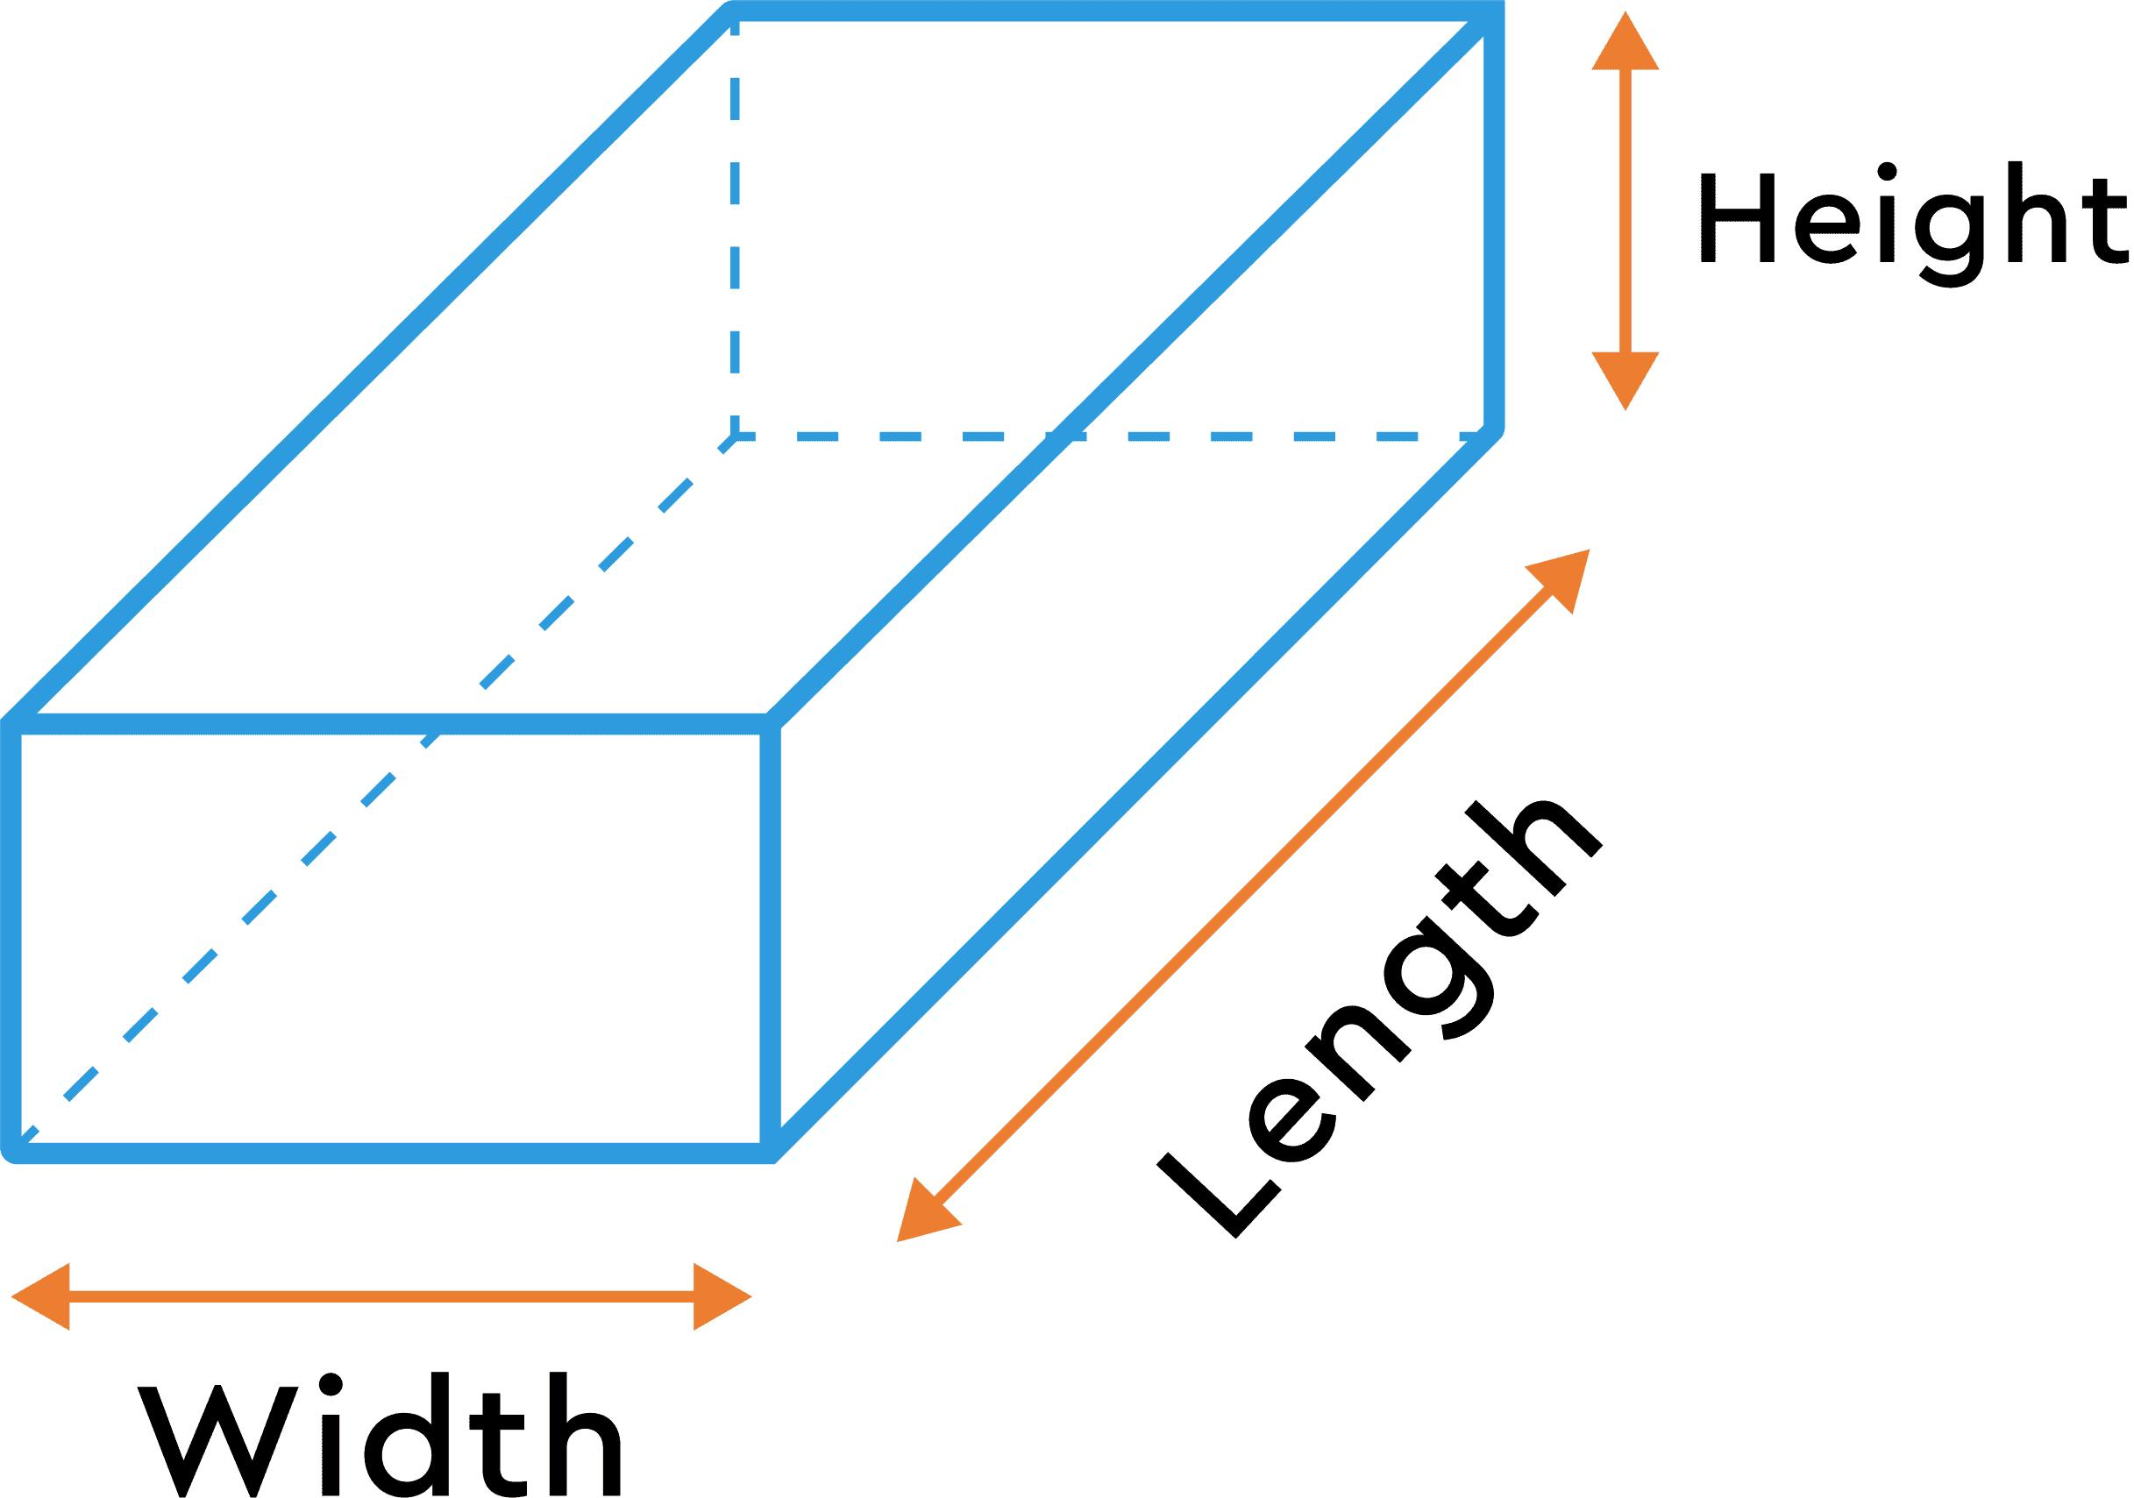
Its volume depends directly on its width:
$$V∝w$$
when length and height remain constant.

Width and Area
# Source: AI Source: Provided by: [Data Path: Persons Table -> ID Column: 1, Name_En Column: Motasem Essam] -> From: [ChatGPT] on [7/20/2026]
For a rectangle:
$$\boxed{A=lw}$$
If the length remains constant, increasing the width increases the area proportionally.
For example:
$$l=10$$
then:
$$A=10w$$
So:
$$w=2⇒A=20$$
and:
$$w=5⇒A=50$$

Width and Perimeter
# Source: AI Source: Provided by: [Data Path: Persons Table -> ID Column: 1, Name_En Column: Motasem Essam] -> From: [ChatGPT] on [7/20/2026]
For a rectangle:
$$\boxed{P=2\left(l+w\right)}$$
Solving for width:
$$\boxed{w=\frac{P}{2}-l}$$
Thus, if the perimeter and length are known, the width can be determined.

Width vs. Length
# Source: AI Source: Provided by: [Data Path: Persons Table -> ID Column: 1, Name_En Column: Motasem Essam] -> From: [ChatGPT] on [7/20/2026]
Width and length are both linear dimensions, but they usually describe different directions.
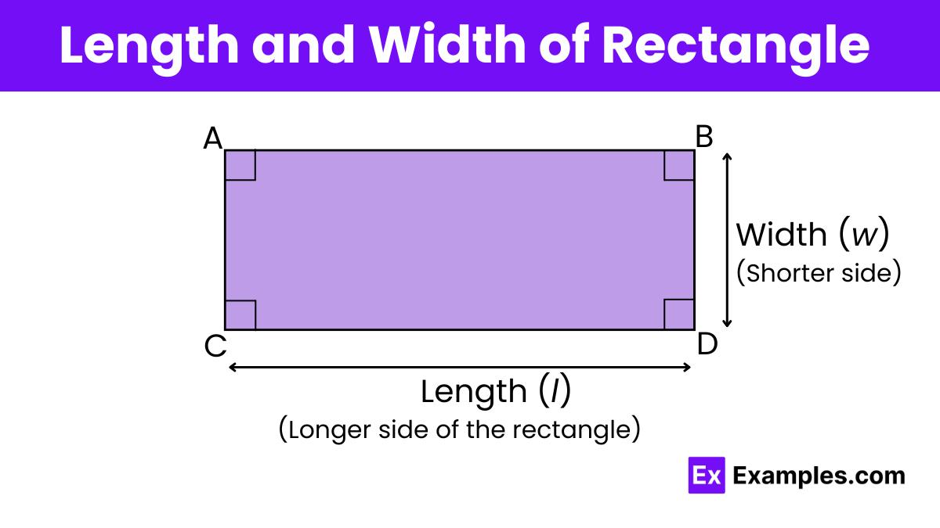
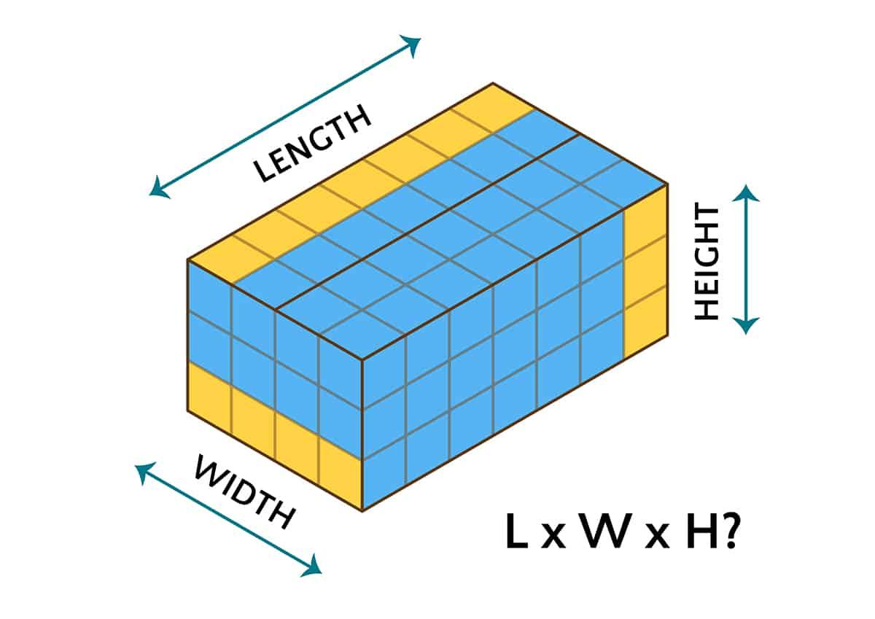
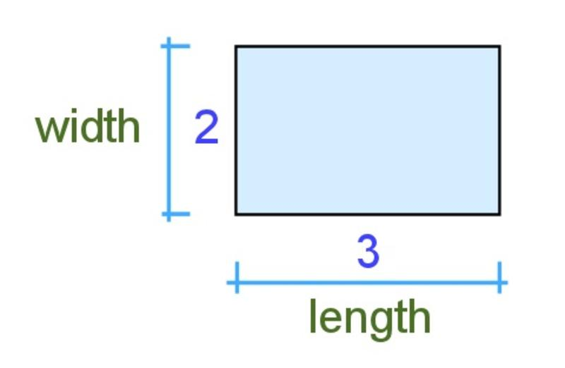
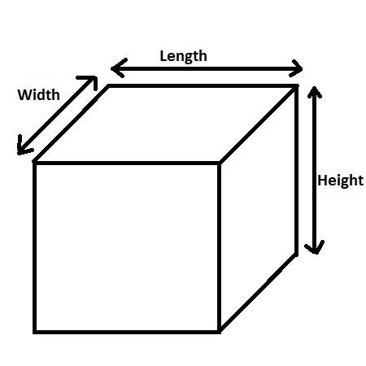
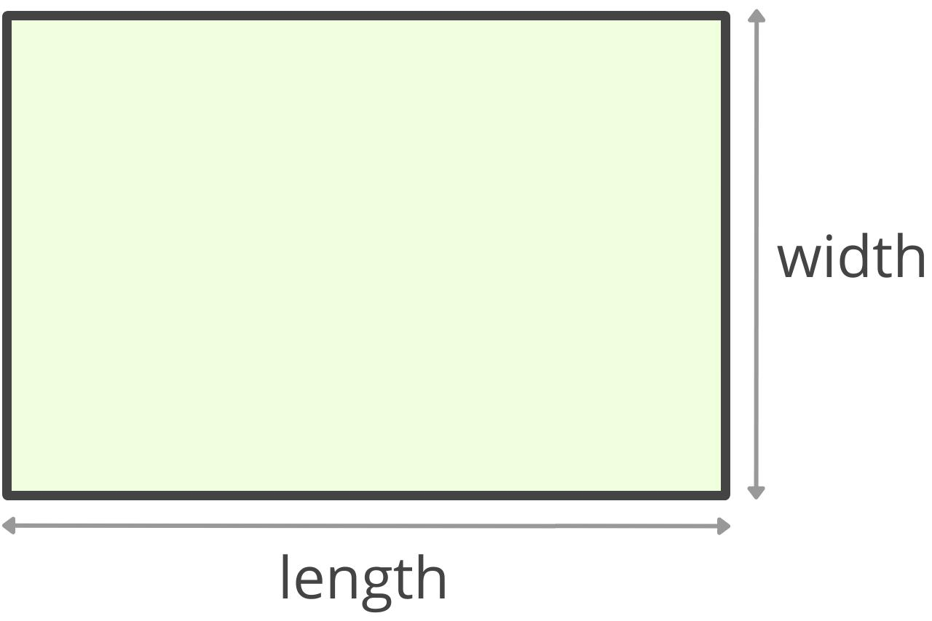
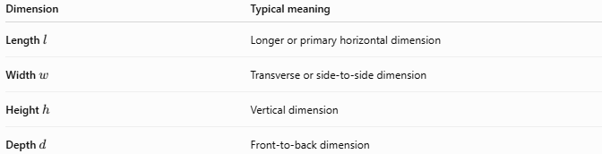
Dimension | Typical meaning
Length $l$ | Longer or primary horizontal dimension
Width $w$ | Transverse or side-to-side dimension
Height $h$ | Vertical dimension
Depth $d$ | Front-to-back dimension
However, these names are conventional rather than absolute. Rotating a figure can change which dimension is naturally called its width.

Width vs. Height
# Source: AI Source: Provided by: [Data Path: Persons Table -> ID Column: 1, Name_En Column: Motasem Essam] -> From: [ChatGPT] on [7/20/2026]
Width and height usually describe perpendicular dimensions:
$$\boxed{w⊥h}$$
For example, in a rectangle:
$$A=wh$$
when the horizontal dimension is designated as width and the vertical dimension as height.
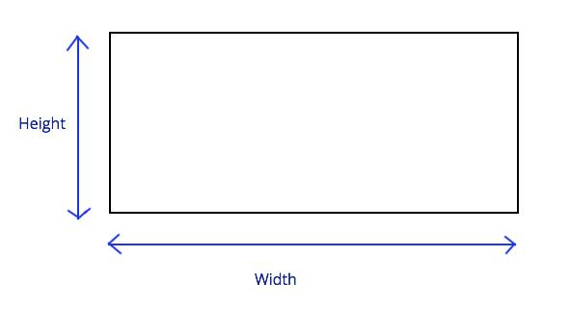
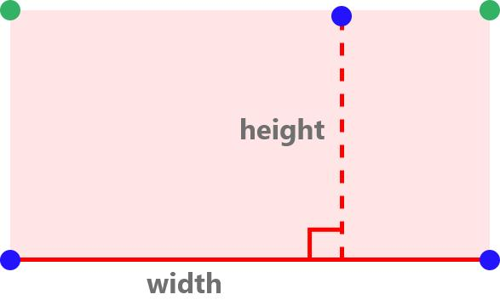
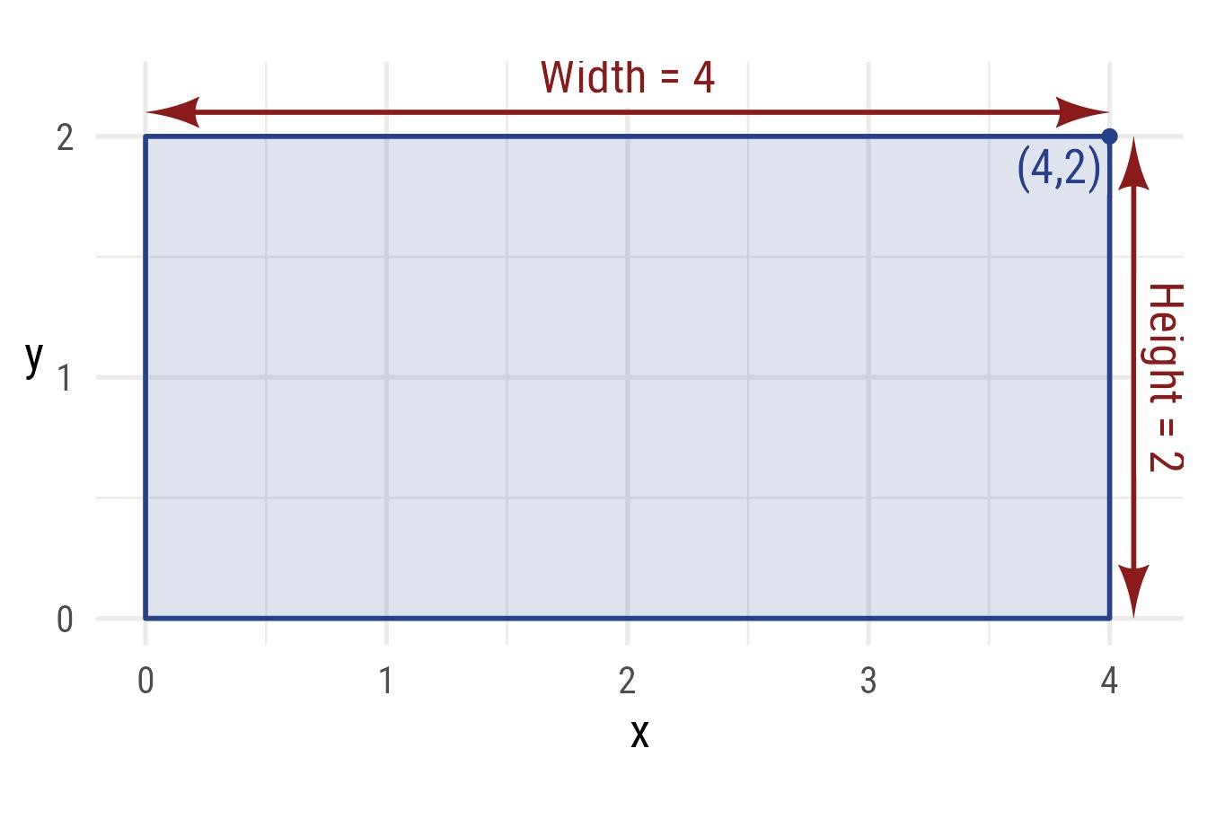
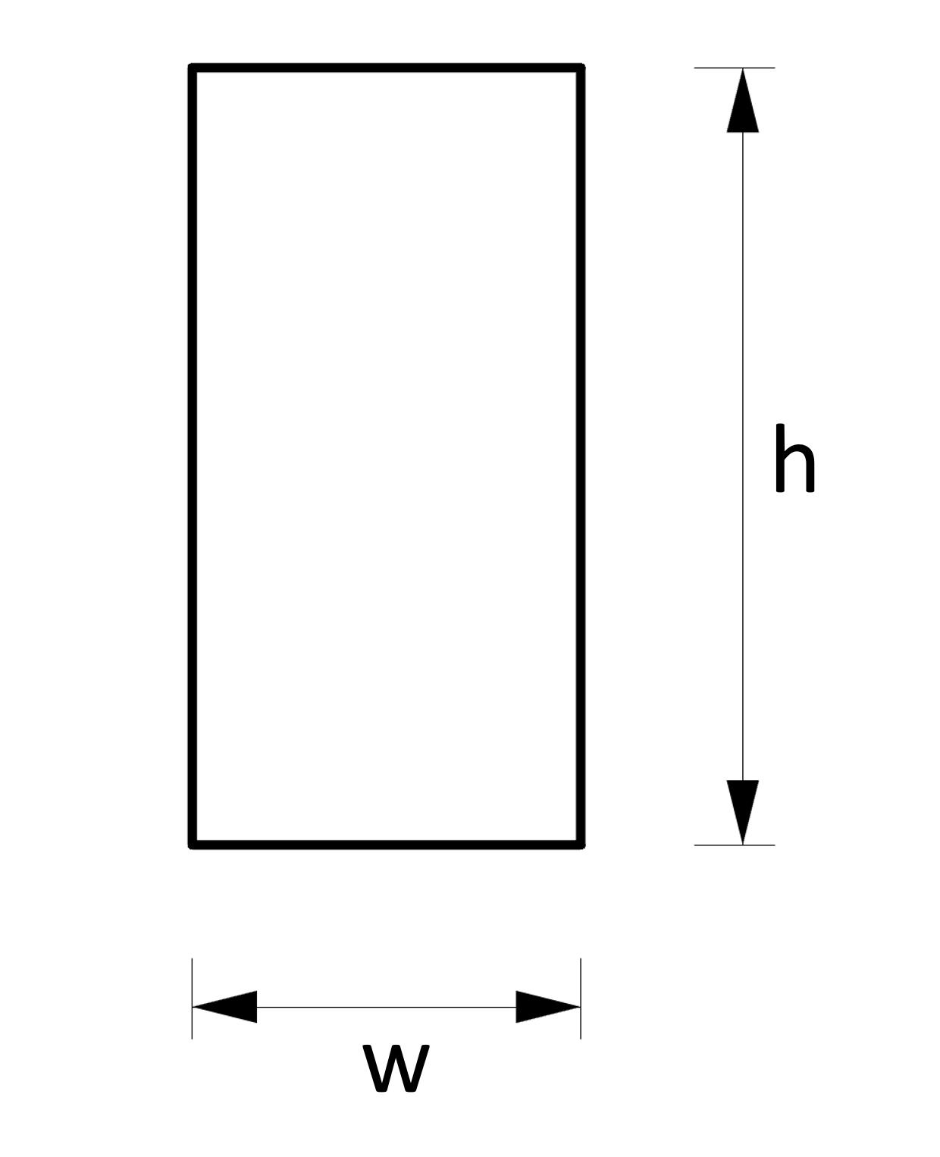

Width vs. Base
# Source: AI Source: Provided by: [Data Path: Persons Table -> ID Column: 1, Name_En Column: Motasem Essam] -> From: [ChatGPT] on [7/20/2026]
These terms should not be treated as identical.
Width describes a dimension or extent.
Base describes a designated reference side or face used for geometric calculations.
For example, in a triangle, one side can be selected as the base, but it is not normally called the width:
$$\boxed{A=\frac{1}{2}bh}$$
Thus:
$$\boxed{\text{Width}≠\text{Base}}$$
in general.

Width in Measurement
# Source: AI Source: Provided by: [Data Path: Persons Table -> ID Column: 1, Name_En Column: Motasem Essam] -> From: [ChatGPT] on [7/20/2026]
Width is fundamentally a linear measurement.
Its dimensions are:
$$\boxed{\left[w\right]=L}$$
where $L$ represents the dimension of length.
Common units include:
- millimeter (mm)
- centimeter (cm)
- meter (m)
- kilometer (km)
- inch (in)
- foot (ft)
- yard (yd)
Width should therefore be expressed in linear units, not square or cubic units.
Correct:
$$w=5\text{ cm}$$
Incorrect:
$$w=5{\text{ cm}}^{2}$$
because ${\text{cm}}^{2}$ is an area unit.

Width in Irregular Shapes
# Source: AI Source: Provided by: [Data Path: Persons Table -> ID Column: 1, Name_En Column: Motasem Essam] -> From: [ChatGPT] on [7/20/2026]
For an irregular shape, there may be no single universally defined width.
Several different measurements may be used, depending on the purpose:
- Maximum width.
- Minimum width.
- Width at a specified location.
- Average width.
- Bounding-box width.
- Cross-sectional width.
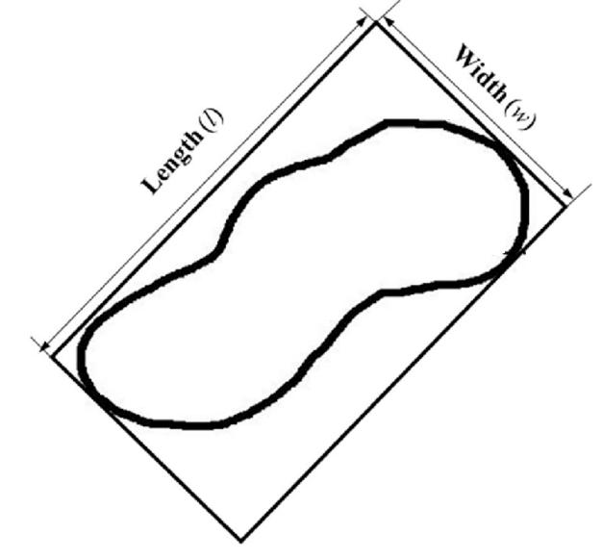
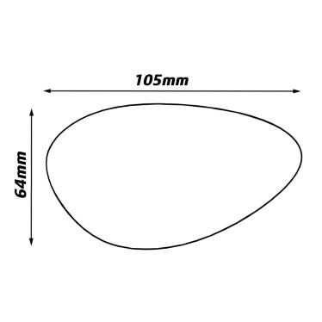
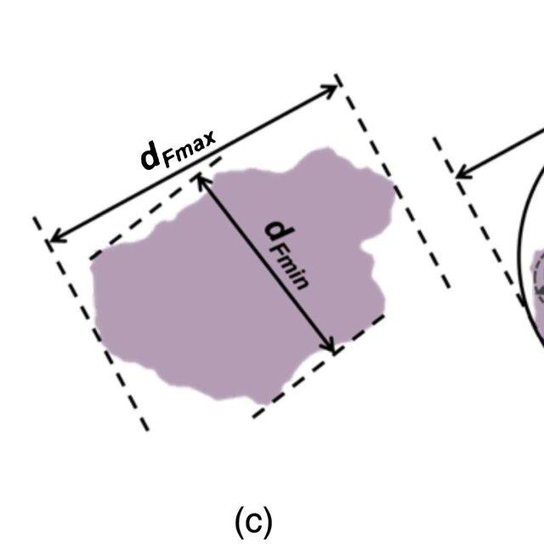
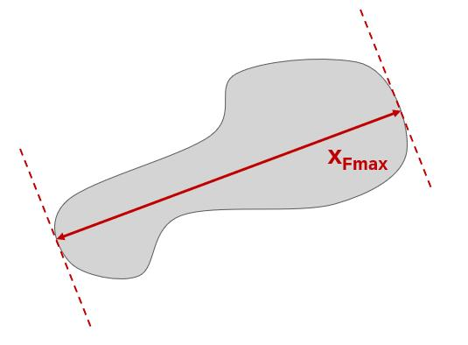
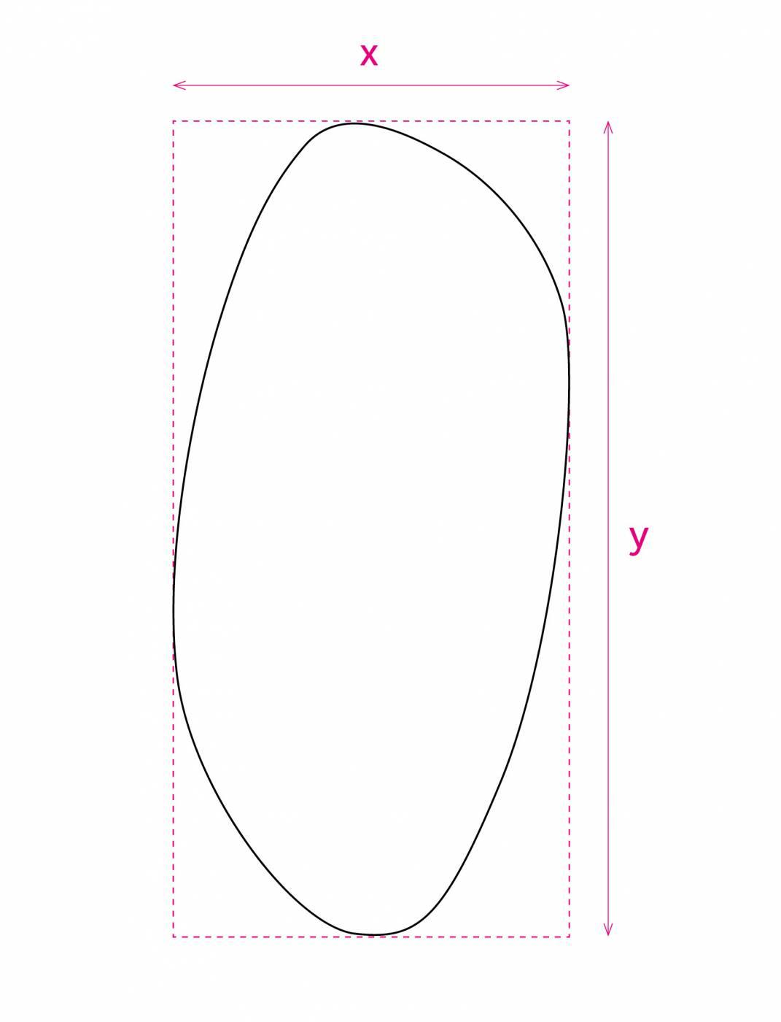
For an irregular shape, it is therefore important to specify how the width is being measured.

Width in 3D Objects
# Source: AI Source: Provided by: [Data Path: Persons Table -> ID Column: 1, Name_En Column: Motasem Essam] -> From: [ChatGPT] on [7/20/2026]
For a rectangular prism:
$$\boxed{V=lwh}$$
and the surface area is:
$$\boxed{SA=2\left(lw+lh+wh\right)}$$
Therefore, width affects both volume and surface area.
If $l$ and $h$ remain fixed:
$$V=lwh$$
shows that volume changes linearly with width.

Applications
# Source: AI Source: Provided by: [Data Path: Persons Table -> ID Column: 1, Name_En Column: Motasem Essam] -> From: [ChatGPT] on [7/20/2026]
Width is important in:
- Geometry
- Measurement Theory
- Engineering
- Architecture
- Technical Drawing
- Mechanical Design
- Construction
- Manufacturing
- Robotics
- Computer Graphics
- CAD (Computer-Aided Design)
- Surveying
- Product Design

Advantages
# Source: AI Source: Provided by: [Data Path: Persons Table -> ID Column: 1, Name_En Column: Motasem Essam] -> From: [ChatGPT] on [7/20/2026]
Understanding width helps to:
- Describe the transverse dimensions of objects.
- Measure the side-to-side extent of regions and objects.
- Calculate area, perimeter, and volume.
- Define the proportions and dimensions of geometric figures.
- Support accurate engineering and architectural designs.
- Determine clearances and available space.
- Support accurate modeling and technical drawings.

Limitations
# Source: AI Source: Provided by: [Data Path: Persons Table -> ID Column: 1, Name_En Column: Motasem Essam] -> From: [ChatGPT] on [7/20/2026]
Width:
- Is a one-dimensional measurement.
- Does not by itself specify direction or orientation.
- Does not describe the complete size of an object.
- May depend on the object's orientation or reference frame.
- May require additional dimensions for three-dimensional objects.
- Does not describe area or volume by itself.

Key Points
# Source: AI Source: Provided by: [Data Path: Persons Table -> ID Column: 1, Name_En Column: Motasem Essam] -> From: [ChatGPT] on [7/20/2026]
$$\boxed{\text{Width}=\text{A Linear Side-to-Side Dimension}}$$
Width:
- Is a length measurement.
- Is often represented by $w$.
- Describes how wide a figure or object is.
- Is commonly paired with length and height.
- Is measured in linear units.
- Determines area in formulas such as $A=lw$.
- Determines volume in formulas such as $V=lwh$.
- Is orientation-dependent in many geometric figures.
- May require a specific definition for irregular shapes.

Conclusion
# Source: AI Source: Provided by: [Data Path: Persons Table -> ID Column: 1, Name_En Column: Motasem Essam] -> From: [ChatGPT] on [7/20/2026]
Width in geometry is a linear dimension describing the extent of a figure or object from one side to the opposite side. It is especially common in rectangles and rectangular solids, where it works together with length and height to determine area, perimeter, surface area, and volume. Unlike the term base, which identifies a reference side or face for a geometric calculation, width primarily describes a dimensional extent. For irregular shapes, width may need to be defined more precisely, such as maximum width, minimum width, local width, or bounding-box width.

